Data Insight Report: "TalentView": HR Attrition & Workforce Dashboard

Team : Data Analytics – Group G1

Team Members: 1.Komal Tanna
2.Mayur Kadamdhad
3.Alan Benny
4.Jaswinder Kaur
Github Link :
https://github.com/Mayur1022/TalentView-HR-Attrition-Workforce-Dashboard-Infotact-Solution-Data-Analytics--G1-

DATASET OVERVIEW:

- HR Analytics Data (Workforce and Attrition)
- Total Records: 1,480
Represents the total number of employees included in the survey.
- Total Columns: 38
Contains detailed employee attributes across demographics, employment, and satisfaction metrics.
Key Fields:
- Demographics: Age, Gender, MaritalStatus
- Employment: Department, JobRole, JobLevel, MonthlyIncome, SalarySlab
- Stability: Attrition (Yes/No), TotalWorkingYears, YearsAtCompany, YearsWithCurrManager
- Satisfaction: JobSatisfaction, EnvironmentSatisfaction, WorkLifeBalance

- Hiring Data
- Total Records: 500
Represents the total number of applications analyzed.
- Total Columns: 16
Covers fields related to candidate progress and offer details.
Key Fields:
- Pipeline Stages: application_date, screening_date, interview_date, offer_date, hiring_date
- Outcome: hiring_status (e.g., Hired, Offered)
- Recruitment Details: source_of_hire, expected_salary, offered_salary

1. Executive Summary (Top-Level Takeaway)
- Our analysis shows that company is facing a high attrition rate of 16.1%, mainly among male employees aged 26-35. Most people leaving are from two roles-Laboratory Technicians (62) and Sales Executives (57)and many of them fall in the lower salary range (up to ₹5,000).
- The Research & Development department has the largest number of employees overall. On the hiring side, things are working fairly well with a 79.56% offer acceptance rate and an average time-to-hire of 16 days.
- However, the 237 exits are creating pressure on the organization. The company needs to understand why employees in key roles are leaving and take steps to improve retention and hiring stability.

2. Objective / Business Question
The main goal of this report is to understand why the company is experiencing high employee attrition and to evaluate how well the current hiring process is working.
This analysis seeks to answer the following business question:
- How can the HR team reduce the 16.1% attrition rate by identifying which gender, age group, salary range, roles, and departments are most affected—and are the current hiring efforts helping maintain a stable workforce or adding to the problem?

3. Key Metrics / KPIs
1.Attrition and Stability Metrics
- Attrition Rate (16.1%)
- Attrition Count (237)
- Count of Employee (Total) (1,470)
- Active Employee / Headcount (1,233)
- Attrition Count by Job Role (e.g., Laboratory Technician: 62)
- Attrition Count by Age Group (e.g., 26-35: 116)
- Attrition Count by Salary Slab (e.g., Upto 5k: 163)

2.Workforce Demographics and Profile Metrics
- Avg Age (37)
- Avg Salary (6.50K)
- Headcount by Department (e.g., Research & Development: 828)
- Headcount by Gender (e.g., Male: 732)
- Avg Years of Service (7.0)

3.Hiring Effectiveness Metrics
- Offer Acceptance Rate (79.56%)
- Total Applications (500)
- Hired Count (218)
- Average Time to Hire (16 days)
- Hiring Pipeline Conversion Rate (43.6% from Total Applications to Hired)
- Source of Hire analysis (e.g., Naukri, LinkedIn, Website)
- Department-wise Hiring (e.g., Research & Development: 75)

- Insights & Findings
Insight 1: High Attrition Among Young, Low-Salary Employees
- Fact: Most employees who left were aged 26–35 (116 employees), and 163 of them were in the lowest salary bracket (up to ₹5,000).
- Why it matters: Losing younger and lower-paid employees shows there may be issues with pay, growth opportunities, or engagement. This also affects team stability and increases hiring and training costs.
- Recommendation: Review salaries in the “up to ₹5k” range and compare them with market standards. Create clear career paths and introduce retention bonuses or growth programs for employees in the 26–35 age group.

Insight 2: Attrition Focused in Two Key Roles
- Fact: Laboratory Technicians (62) and Sales Executives (57) together make up almost half of all exits (119 out of 237).
- Why it matters: Because the problem is concentrated in specific roles, the issue may be linked to workload, work conditions, or management in those areas. Losing people from these roles hits operations directly.
- Recommendation: Conduct focused exit/stay interviews for these two roles. Understand what’s causing dissatisfaction. Build a backup plan—like cross-training—to avoid shortages when attrition spikes.

Insight 3: Higher Attrition Among Male and New Employees
- Fact: 63% of employees leaving are male, which aligns with the current workforce (59.37% male). Attrition is also high among employees with less than 2 years of experience.
- Why it matters: The company is losing its largest employee group and losing new hires before they settle in. This suggests onboarding, early engagement, or workplace expectations may not be strong enough.
- Recommendation: Start a mentorship program for new employees during their first 1–2 years. Review exit feedback to understand if male employees face specific challenges in the workplace.
Insight 4: Hiring Pipeline Efficiency is Average
- Fact: Offer Acceptance Rate: 79.56%
Average Time to Hire: 16 days
Application-to-Hire Conversion: 43.6%
- Why it matters: These numbers show the hiring process is working but could be better. A slightly low acceptance rate and a moderate hiring speed may cause good candidates to choose other offers.
- Recommendation: Compare the 16-day hiring time with competitors. Collect reasons for declined offers to pinpoint issues—such as salary, job title, or slower process—and adjust accordingly.
Insight 5: Hiring Does Not Match High-Attrition Roles
- Fact: Research & Development has the highest hiring count (75 hires), but the roles with the most exits—Laboratory Technician and Sales Executive—aren’t being hired as aggressively.
- Why it matters: Hiring is aligned with department size, not with the areas facing the highest turnover. This creates ongoing gaps in critical job roles.
- Recommendation: Prioritize hiring for Laboratory Technicians and Sales Executives until their teams stabilize. Redirect hiring resources toward these high-attrition roles for faster recovery.

5. Supporting Visuals (Dashboard)
"TalentView": HR Attrition & Workforce Dashboard

- WORKFORCE OVERVIEW

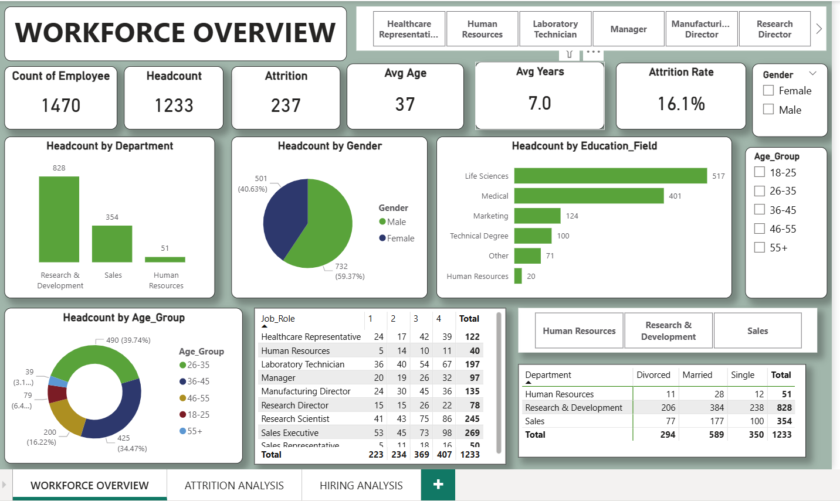

- ATTRITION ANALYSIS

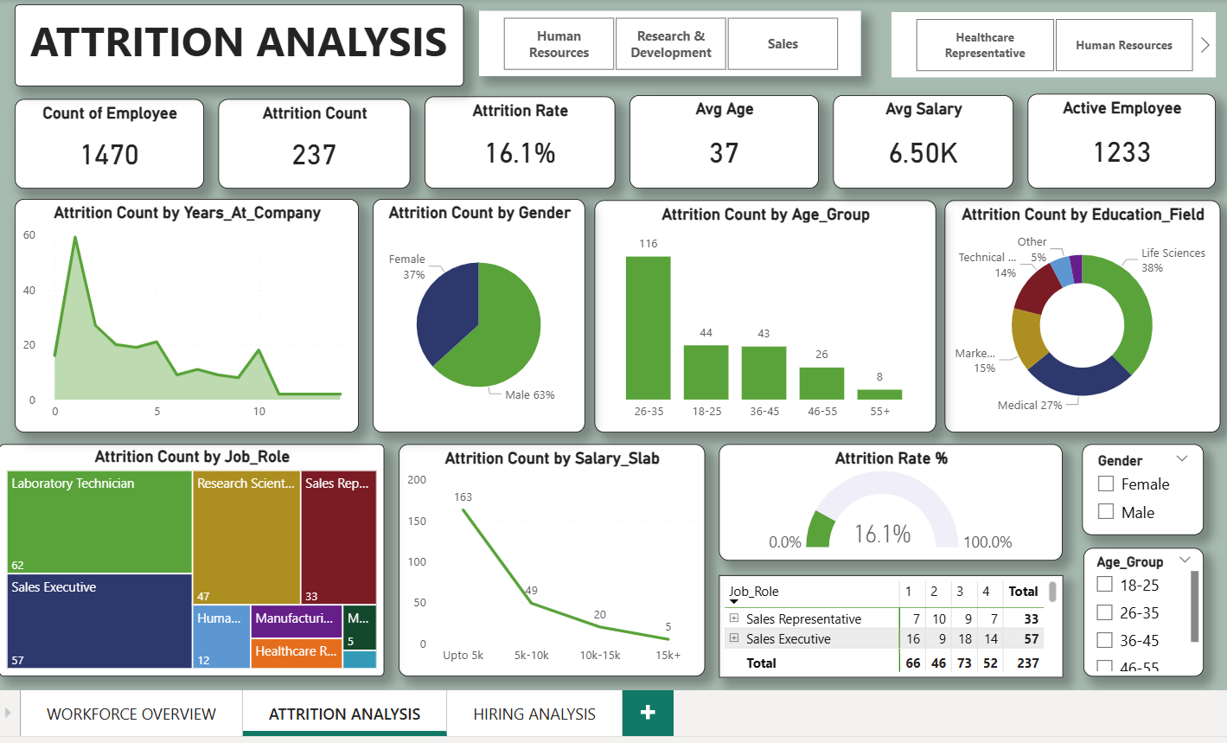

3.HIRING ANALYSIS

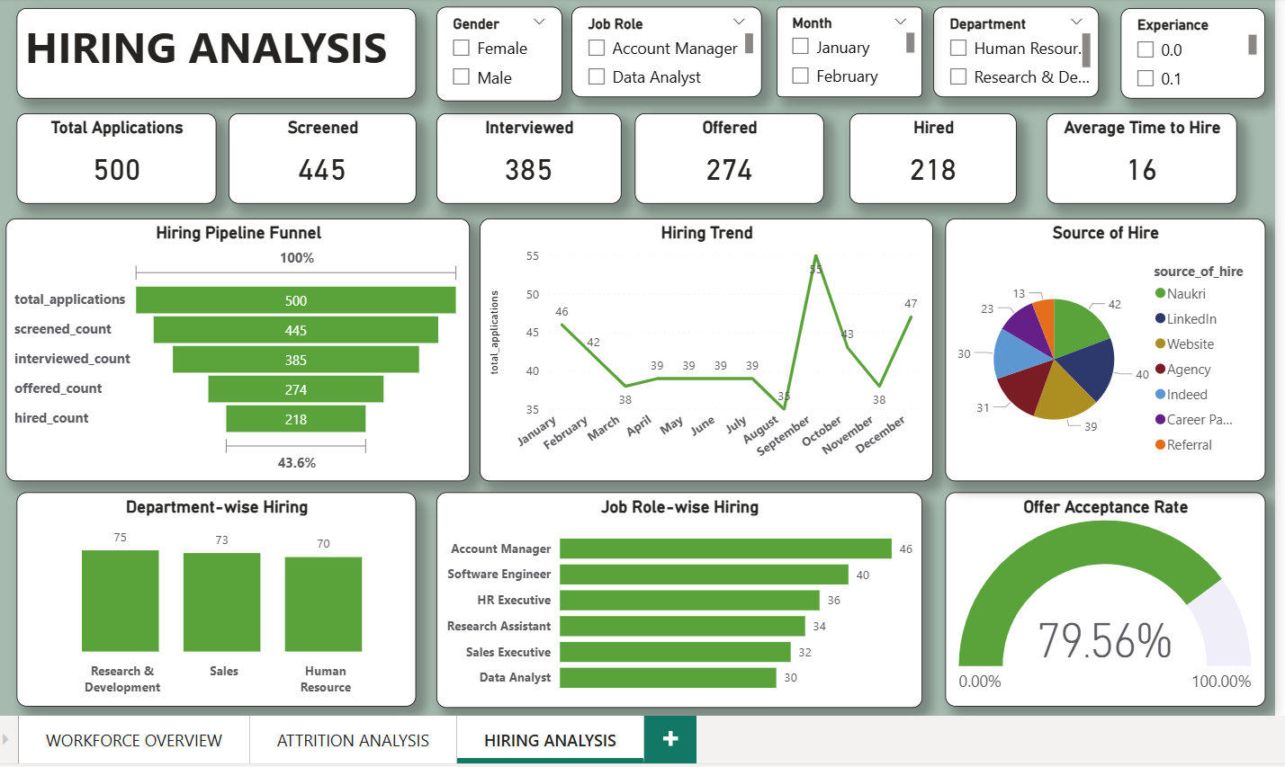

6. Next Steps / Recommendations
Phase 1: Immediate Steps to Reduce Attrition
1. Talk to Employees to Find Real Issues
Start taking detailed exit and stay interviews for:
- Laboratory Technicians
- Sales Executives
- Employees aged 26–35
The aim is to understand what is actually troubling them—like manager behaviour, workload, lack of support, or growth issues.

2. Check and Fix Salary Gaps
Review the salaries of employees who fall in the “up to 5k” range, especially Lab Technicians (because 163 of them left).
Make sure their pay matches market rates so they don’t feel underpaid compared to others.

Phase 2: Improve Hiring Strategy
1. Focus on Hiring for High-Attrition Roles First
Give priority to filling roles where the attrition is high:
- Laboratory Technicians
- Sales Executives
This will stabilize the teams before starting heavy recruitment for other roles like R&D.

2. Make the Offer Process Faster and More Attractive
Study why candidates are rejecting offers.
Check if the 16-day hiring process is too slow or if the offer package needs improvement.
Make the offer approval process faster and personalize the offer where possible to increase the acceptance rate to 85% or more

